tnhttp://globalhealth.harvard.edu/curricula-slides-reading#FS This is a really great resource!!!!***

http://mdgs.un.org/unsd/mdg/Resources/Static/Products/Progress2013/Snapshots/NAM.pdf

- http://www.afro.who.int/index.php?option=com_content&view=article&id=1045&Itemid=1928&lang=en
  - file:///Users/katiesilverman/Downloads/Namibia-who-ccs-2010-2015-abridged-version.pdf

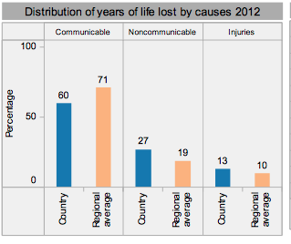
Social/ Health
- Diseases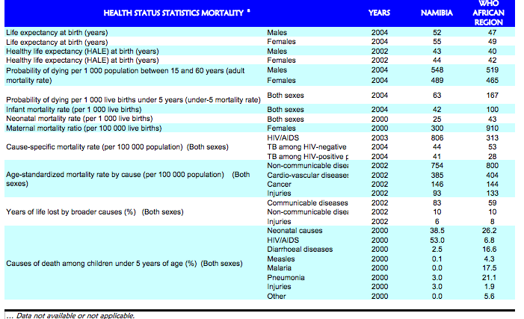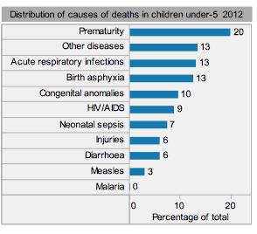
  - Mortality-Katie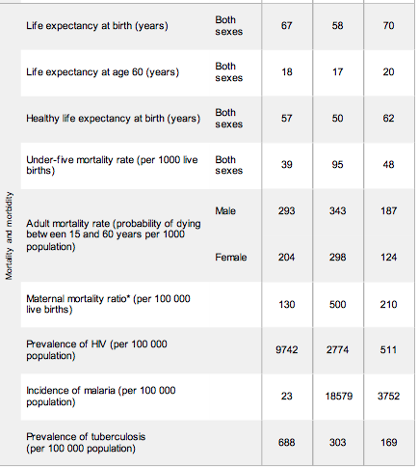
  - Statistics -Katie
    - different diseases that are prevalent

- HIV/AIDS-Olivia
http://www.unicef.org/infobycountry/namibia_statistics.html

HIV/AIDS | to the top
Adult HIV prevalence (%) 2012 | 13.3
People of all ages living with HIV (thousands) 2012, estimate | 220
People of all ages living with HIV (thousands) 2012, low | 190
People of all ages living with HIV (thousands) 2012, high | 250
Women living with HIV (thousands) 2012 | 120
Children living with HIV (thousands) 2012 | 18
Prevention among young people (aged 15-24), HIV prevalence among young people (%) 2012, total | 3.2
Prevention among young people (aged 15-24), HIV prevalence among young people (%) 2012, male | 2.2
Prevention among young people (aged 15-24), HIV prevalence among young people (%) 2012, female | 4.1
Prevention among young people (aged 15-24), Comprehensive knowledge of HIV (%) 2008-2012*, male | 61.9
Prevention among young people (aged 15-24), Comprehensive knowledge of HIV (%) 2008-2012*, female | 64.9
Prevention among young people (aged 15-24), Condom use among young people with multiple partners (%) 2008-2012*, male | 82.2
Prevention among young people (aged 15-24), Condom use among young people with multiple partners (%) 2008-2012*, female | 73.7
Orphans, Children orphaned by AIDS (thousands) 2012 | 76
Orphans, Children orphaned due to all causes (thousands) 2012 | 130
Orphans, Orphan school attendance ratio (%), 2008-2012*
http://www.unaids.org/en/Regionscountries/Countries/Namibia/
HIV/AIDS estimates in 2013:

Number of people living with HIV | 250,000 [210,000 - 290,000]
Adults aged 15 to 49 prevalence rate | 14.3% [11.8% - 17.3%]
Adults aged 15 and up living with HIV | 220,000 [190,000 - 260,000]
Women aged 15 and up living with HIV | 130,000 [110,000 - 150,000]
Children aged 0 to 14 living with HIV | 23,000 [18,000 - 28,000]
Deaths due to AIDS | 6,600 [4,000 - 10,000]
Orphans due to AIDS aged up to 17: | 96,000 [12,000 - 130,000]

Note:
- Primarily heterosexual transmission
- Recent increases in rates (especially of women in their 40s) could be because of the improvements of ARV’s
- Generally most prevalent in the northern area of the country along the Angola border
http://www.cpc.unc.edu/measure/publications/sr-09-53
“Forced labor migration, segregation of men from their families and communities, institutionalized racism, and imposed poverty are believed to have contributed to the spread of HIV to its current proportions, as did years of civil strife within Namibia and in neighboring countries.” (pg 1)
Risk Factors of HIV/AIDS:
- Multiple and concurrent partnerships- more than one partner in a short period of time
  - At the current population size, each HIV positive person only needs to infect one other person to keep the epidemic at its current rate.
  - This behavior is very common among people under 30 years of age, which leads to the infection of many youths.
  - It was found that divorced/widowed/separated women are more likely to have multiple concurrent partnerships than other women.
  - There has been steady decline in cohabitation/marital relationships.
- Intergenerational sex- exposes youth to those who are much more likely to be HIV positive
  - It exposes youth to people who are much more likely to be HIV positive.
  - Usually, the proportion of the population with HIV increases with age (because there is exposure to more sexual partners).
  - This form of sexual activity is more common among young married and cohabiting women than other women, because they are more likely to have a partner much older than them.
  - A lot of men want younger women for partners because they are less likely to have been exposed. Some relationships are forced on girls as young as 10-14.
  - There is a decreased likelihood of condom use when unmarried and with an older partner.
  - Intergenerational marriages occur at a much higher rate in areas where HIV is most prevalent (Omusati and Ohangwena).
  - There are high rates of nonmarital intergenerational sex iin Erongo, Hardap, and Omaheke.
- Alcohol abuse- helps to overlook the risk of HIV
- Low levels of HIV risk-perception/condom use
  - Many people know about HIV/AIDS. There is more of a lack of risk-perception that is associated with it.
  - The risk of infection is often viewed as a concern, but not a major one.
  - Poverty takes priority. It is a much more immediate concern than the potential development of HIV later on in life.
  - Common misconceptions about condom use:
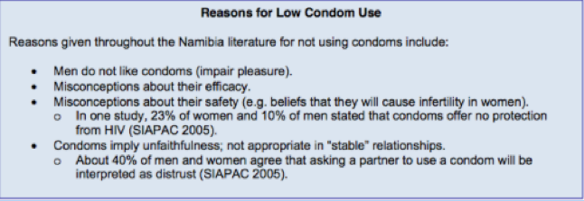
- Poor working conditions, especially for miners
  - They feel that they are going to die soon anyway, so there is no reason to worry about protecting themselves.
  - Also, with some of the dangers of working, people may be exposed to others blood which is problematic if it gets in the other person’s open wounds.
- Steady decline in cohabitation/marital relationships
  - In 2006, 1 out of 3 people ages 35-39 have never done this.
- Transactional sex
  - This is very common in Namibia, because there is a lot of poverty and not a lot of opportunities for employment.
  - It is very difficult for women to be economically independent.
  - There are not a lot of employment opportunities in comparison to men.
  - Often civil servants, migrants, and seasonal workers engage in this.
  - The financial rewards tend to outweigh potential health concerns.
- Population mobility
  - Those who move tend to have higher levels/are more susceptible to HIV than those who do not
  - Urbanization
  - Mines, fisheries, military bases, large construction sites where they are hiring lots of male workers- have money and therefore are able to afford alcohol and transactional sex
  - Females moving around do not have as many employment options or legal protection- often alone and therefore often fall victim to sexual abuse and violence. They are likely to engage in transactional sex.
Population at the highest risk- young women
- These women are usually married/cohabiting, poor, and uneducated
- Risk mostly comes from partner’s behavior- The spouses expose them to the infection.
- Women are unable to have much control in sexual relationships/ negotiation of condom use.
http://www.who.int/hiv/pub/guidelines/namibia_art.pdf
Treatment of HIV/AIDS
Treatment started in 2003 with 6 hospitals using HAART (Highly Active Antiretroviral Therapy). It soon expanded to remaining 28 state hospitals.
There are now six different types of ARV’s:
- Nucleoside Analogue Reverse Transcriptase Inhibitors (NRTIs).
- Non-Nucleoside Analogue Transcriptase Inhibitors (NNRTIs).
- Protease inhibitors (PIs).
- Fusion inhibitors
- Intergrase inhibitors
- CCR5 entry inhibitors
Potential Prevention Methods of HIV/AIDS
It might be more effective to attempt to educate Namibians about HIV/AIDS and advocate for a change in social norms than it is to encourage them to change their behaviors.
  - Giving women access to education and employment opportunities (especially in urban areas)
    - This has been very effective
  - Increase the perception of risk among men
    - Teach the importance condom use and less multiple/concurrent partners
  - Focus on educating migrant workers
    - This targets the ease of spread of infection due to population mobility.
http://news.bbc.co.uk/olmedia/590000/images/_590315_namibia_300map.gif picture
- Ebola-Haley
  - The CDC has only reported one 2 cases of Ebola in the southern part of Africa and only one resulted in death. These cases were reported in 1996 and the southern part of africa has not seen any cases of ebola since.
  - the closest ebola outbreak to namibia is in the democratic republic of the congo but otherwise, the affected countries are those in western africa
  - During 2014, there have been 3626 reported cases, 1837 of them resulting in death. These numbers represent laboratory confirmed cases only
  - http://www.namibiansun.com/health/namibia-angola-discuss-drc-ebola-outbreak.70626 (namibia and ebola preparation)
  - http://www.namibtimes.net/forum/topics/law-enforcement-agencies-receive-training-on-ebola
  - 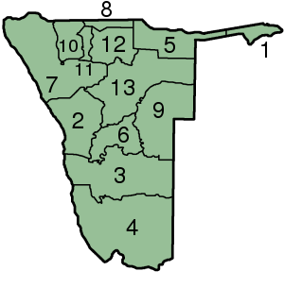training starts in 13-->2, 3, 4
- Maternal Mortality--Kendra

Major causes of Maternal & Child Mortality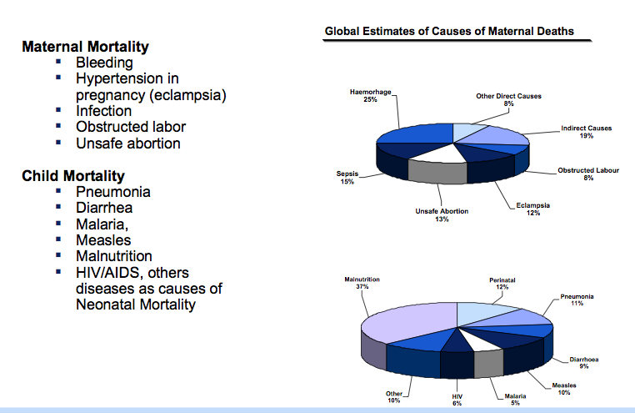

In 2012
- 28 deaths per 1,000 live births
- 39 deaths per 1,000 live births
- Most prominent causes of death for children below the age of 5
  - prematurity (19%)
  - HIV/AIDS (14%)
  - Pneumonia (12%)
- 2007-2011
  - Maternal Mortality ratio→ 450 per 100,000 live births

Situational Overview:
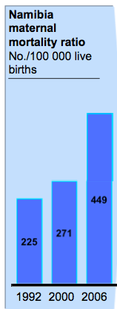
Key issues:
- Lack efficiency to screen and take appropriate measures for those in pregnancy
- structural constraints (poor road infrastructure/ transportation) plays in the role of access & servicing maternal health services
- Lack of access to skilled health care providers
Future Goal: “A locally developed and well coordinated approach will be reqiured to deliver long term and sustainable improvement in maternal health outcomes.”
http://www.commonwealthhealth.org/africa/namibia/child_and_maternal_health_in_namibia/

Reproductive Health Indicators
Fertility & Contraception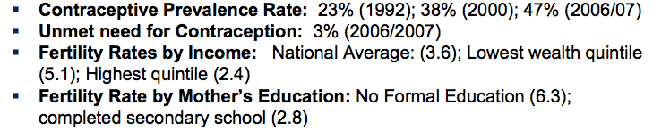
Unplanned Pregnancies (From the NDHS 2007)
- ⅔ of births in Namibia are unintended
- 41% of births in Namibia are unwanted
- 22% of Births in Namibia are mistimed
- If all unwanted/not intended births were avoided, then the average fertility rate would be 2.7 rather than 3.6 (what does the avg. fertility rate tell us?)

Teenage Pregnancies
- 15% of teenage girls have began childbearing
  - These girls are at high risk of obstetric emergencies and maternal mortality
  - 50% of the teenagers with no education have given birth
vs
  - 6% of teenagers who complete/are completing secondary school

Maternal Health Indicators
- 68.4% of rural women have at least 4 ANC visits during pregnancy
- 73 % of urban women have at least 4 ANC visits during pregnancy
- 59% of births in the lowest quintile that take place in a health facility
- 97.3% of births in the highest quintile take place in a health facility

http://www.ctc-health.org.cn/file/es2010101905.pdf

MOHSS Maternal and Newborn Roadmap based on four objectives and multiple strategies
26 October 2010
Objective 1: Provide quality maternal health care services at all levels of health care delivery
1.1 Availability & provision of quality maternal & neonatal care
Provide quality maternal 1 health care services at all
1.2 Institutionalise routine MDRs1 (Maternal Death Reviews), National CEMD2 and verbal autopsies
levels of health care delivery
1.3 Empower communities to improve RH and MNH
Increase the utilisation of health 2 facilities for maternal and
1.4 Establish a functional enabling environment
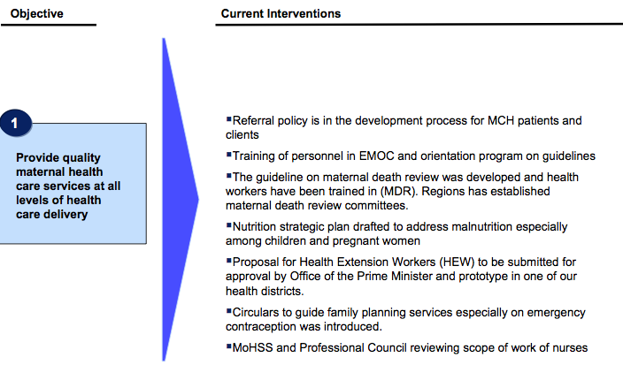

Objective 2: Increase the utilisation of health facilities for maternal and newborn health
2.1 Creation of an enabling environment
newborn health
2.2 Strengthen planning, implementing, monitoring and evaluation of services
2.3 Resource mobilisation for improved MNH and FP
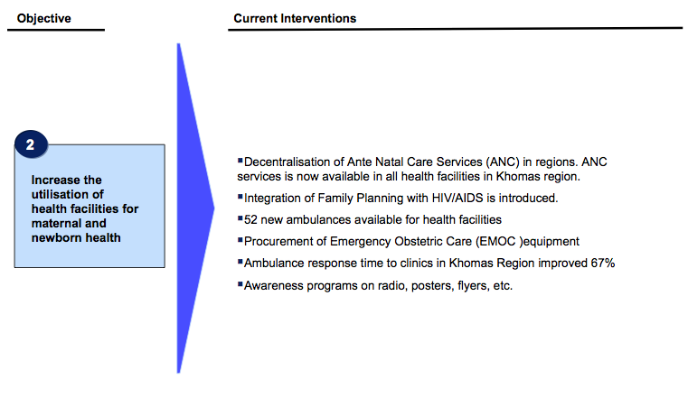

Objective 3: Provide quality neonatal 3 services at all levels of healthcare delivery
3.1 Availability of quality emergency newborn care
healthcare delivery
3.2 Newborn health integrated with existing health programmes
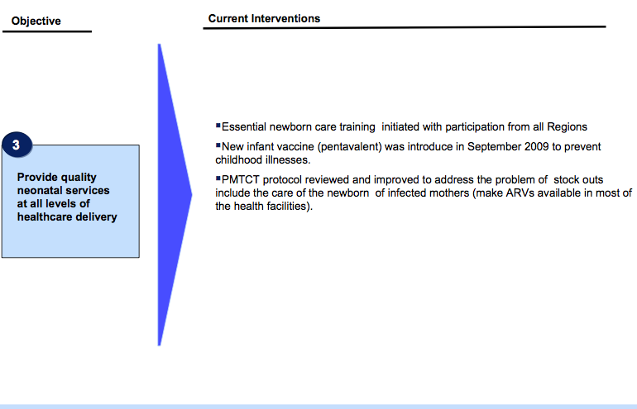

Objective 4: Provide adolescent friendly health services at all levels of
healthcare delivery
4.1 Create an enabling environment for sexual and RH
4.2 Strengthen adolescent sexual and RH services
Objective 5: Leadership & Management

Challenges that are approached

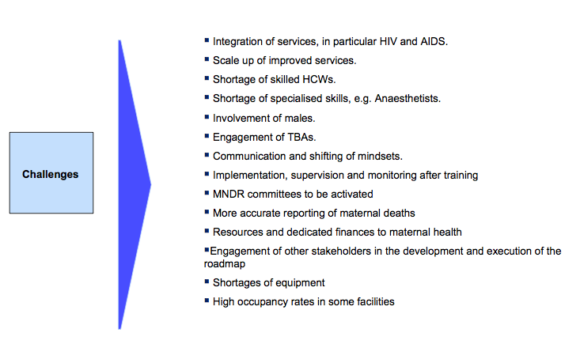
SOURCE: MOHSS, Roadmap for Accelerating the Reduction of Maternal and Newborn Morbidity and Mortality
Reaching Millenium Goal:

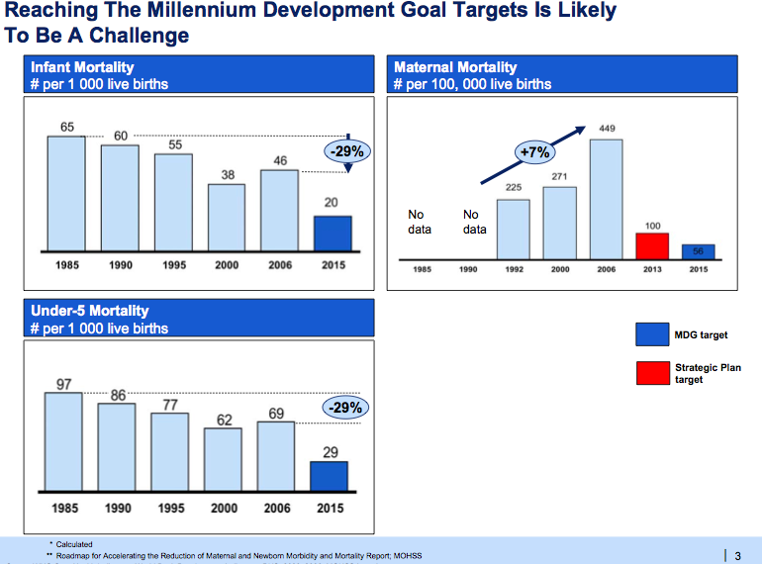
￼￼￼￼￼￼￼￼￼￼￼￼￼￼￼￼￼￼￼ Action

  - Almost 90% of total health spending on reproductive health was funded by the government (2008/2009) which has decreased from 93% in 2007/2008.
    - There was a decline in reproductive health spending because maternal and child mortality rates are increasing among the poor repote and the uneducated.
  - The nation has created a Reproductive Health Roadmap
    - Goals: to Strengthen availability, access and provision of quality maternal and child health services, evaluating and other aspects.
    - By implementing this road map, Namibia must strongly emphasize Reproductive health using sustainable methods

http://www.unicef.org/namibia/health_nutrition_13649.html

http://www.unicef.org/namibia/survivalnewborn-sidebar4.jpg

- UNICEF Effort
  - Survival of newborns and mothers
  - The goal is to keep mothers and babies both alive and healthy
  - Maternal mortality has almost doubled since 2000 (200/10000 live births)
  - There was a national assessment of maternal and newborn care services in 2006:
    - This assessment identified gaps and informed the development of a National Plan
    - During this assessment, it was discovered that only 4 of 100 assessed health facilities were providing all necessary services.
    - No health facilities in the north regions (very populated) were capable of saving lives
    - 4 regions in the North→ 63% of maternal deaths were recorded from 4 regions in the north.
    - Strategic Objective 1 of the National Road Map is: “Provision of quality maternal and newborn health services at all levels of the health delivery system including strengthening referral systems.”
    - Hopeful Outcomes:
      - By the end of 2018→ 85% of mothers, adolescents and children under 5, including the most vulnerable populations in remote and urban areas, will be benefit from access to integrated health care services.
- Main policies governing maternal and newborn health
  - The National Policy on Infant and Young Child Feeding (2007)
  - National Policy for Reproductive Health (2001)
  - Efforts to better skills of health workers so that mothers have quality services during pregnancy and after the birth.
  - 2011-2015 Strategic Plan for Nutrition includes:
    - Strategic priorities to improve maternal nutrition and better maternal health and reductions in neo-natal (first 28 days of an infant’s life) and infant mortality rates
  - In 2010 a Road Map for Accelerating the Reduction of Maternal and Neonatal Morbidity and Mortality was created
    - This guided officials to quality maternal and neonatal health care
    - Health MDGs?
  - This is a great report called the “National Guidelines on Infant and Young Child Feeding” → http://www.ctc-health.org.cn/file/es2010101905.pdf

http://www.aho.afro.who.int/profiles_information/index.php/Namibia:Analytical_summary_-_Maternal_and_newborn_health
*The following information is from 2006-2007, so it was not in the powerpoint; however, it is good information to compare to recent statistics and see where the country was 8 years ago.*
- Perinatal mortality rate-29/1000 pregnancies (right before/right ater)
- Early neonatal mortality → neonatal mortality=20/1000 pregnancies--52% of under 5 mortality
- Infant mortality declined from 71/1000 in 1980 to 45 in 2006
- Under-five mortality rate → 61 deaths per 1000 live births
  - In 1980 there were 108 deaths per 1000 live births

- 2006/2007→ upwards trend in infant and under-five mortality as compared to 2000.
- Maternal mortality rate has increased from 271 deaths in 100,000 live births (2006/2007)
- Direct causes of maternal deaths are eclampsia, complications with labor/abortion.
  - Indirect causes→ high HIV/AIDS prevalence in Namibia
- 18% of pregnant women have been tested HIV positive
- Malaria infections are an indirect cause of maternal deaths and pregnant women are more prone to malaria infections

- Under-five mortality is 1.3 times higher in rural areas than in urban areas
- The under-five mortality rate is almost double in the lowest wealth class when compared to children in the highest wealth class.
- Ohangwena→ this region has the highest under-five mortality rate
  - 95 children per 1,000 live births died before they reached the age of five
- 2006/2007→ 14% of babies were too light for their gestational age
  - Increase from 5.7% (1992) to 8% (2000)
- 30% of children are stunted because of poor nutritional conditions--14% of children born in 2006/2007 had a low birth weight. Women suffer from pregnancy complications because of lack of calories.

- More than 15% of teenagers are pregnant with their first child or already have had a child
- Namibian society favors large families
- Fertility rate → 3.6 (lower than 2000)

- It makes sense that coverage of interventions is higher for the wealthier class.
- Most pregnant women receive antenatal care.
- Most visit a health during the fourth month
- More than 70% of women reported at least 1 serious problem to accessing health care when sick
- Antenatal care quality→ more than 90% of women were wieghed and had blood pressure measured/blood & urine sample taken but only 58% of women were told of signs of pregnancy complications.
- according to DHS of 2006/2007→ almost 60% of all births occurred in rural areas
  - 81% of all births occurred in a health facility
- Every day more than 10,000 newborn babies die because pregnant women do not have access to skilled emergency care
  - 2005/2006 survey of the Namibian hospitals discovered that only 4 of the 34 hospitals have comprehensive emergency care.
  - The 4 hospitals that have all eight signal functions (comprehensive emergency Obstetric care) are not in the highly populated northern areas. Locations: 2 in Windhoek (capital)
1 in Otjiwarongo
1 in Oshakati

- Postnatal check-up
  - in 2006/2007 DHS--65% of mothers have a postnatal check-up within 2 days of live birth
  - many of these women have their check-up within four hours of the birth
- Main policies governing maternal and newborn health
  - The National Policy on Infant and Young Child Feeding (2007)
  - National Policy for Reproductive Health (2001)
  - Efforts to better skills of health workers so that mothers have quality services during pregnancy and after the birth.
  - 2011-2015 Strategic Plan for Nutrition includes:
    - Strategic priorities to improve maternal nutrition and better maternal health and reductions in neo-natal (first 28 days of an infant’s life) and infant mortality rates
  - In 2010 a Road Map for Accelerating the Reduction of Maternal and Neonatal Morbidity and Mortality was created
    - This guided officials to quality maternal and neonatal health care
    - Health MDGs?
  - This is a great report called the “National Guidelines on Infant and Young Child Feeding” → http://www.ctc-health.org.cn/file/es2010101905.pdf
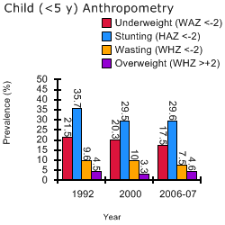
Nutrition- (Claire)
- http://scalingupnutrition.org/sun-countries/namibia
  - Malnutrition (general)= vital nutrient deficiency
    - “Protein-calorie-malnutrition (PCM)”
    - According to the World Health Organization, approximately 117 million children worldwide were stunted by malnutrition in 2010
  - Underweight= low weight for age
  - Stunted=low height for age
  - Wasted= low weight for height
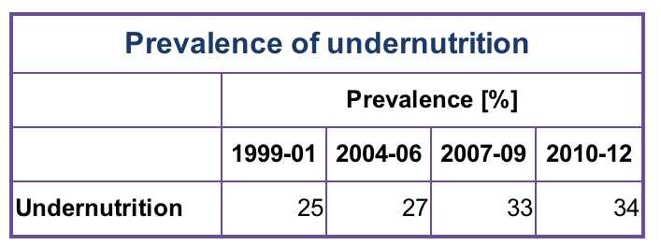
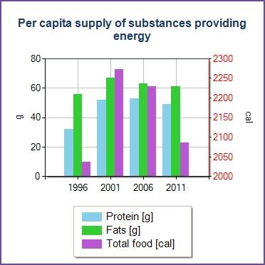
- http://faostat.fao.org/site/666/default.aspx

  - 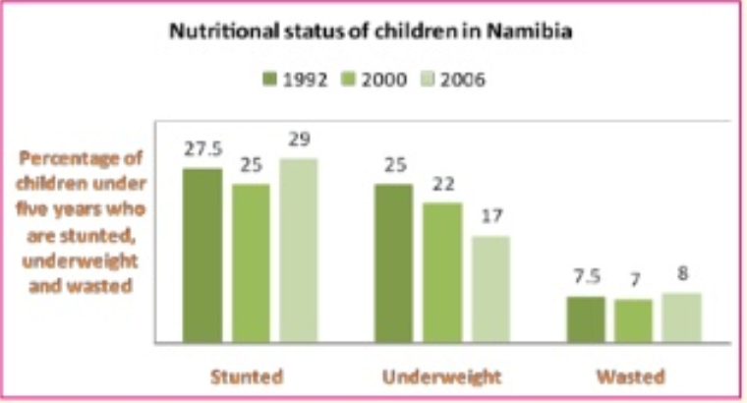
- Over 23% of children in Namibia have vitamin A deficiency
  - Diarrheal & respiratory diseases
  - Vision loss
  - 2 way relationship with infectious diseases
- Causes:
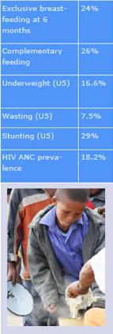
  - Food insecurity
    - 19% of households are food insecure
    - Quality & quantity of food access
  - Breastfeeding
    - Lack of consistent breastfeeding
    - Underweight mothers during pregnancy/breastfeeding
  - Sanitation
    - Diarrhea due to poor sanitation
  - High prevalence of nutrient compromising diseases
    - HIV/Aids
    - Malaria
- Effects:
  - 1 in 4 Namibian children has reduced capacity to learn because of iodine deficiency
  - Leads to diseases in adulthood- diabetes, heart disease, reproductive systems failing, constrained cognitive & physical development
  - Country can’t industrialize (World Bank)
    - Less ppl adding to the GDP
  - http://siteresources.worldbank.org/NUTRITION/Resources/281846-1271963823772/Namibia121710screen.pdf
- Treatments
  - The Ministry of Health is implementing nationwide programs including:
    - Vitamin supplementation
      - Vitamin A, iron & folic acid
    - deworming
    - zinc treatment for diarrhea
  - Cross-sector ministries:
    - Agriculture, social protection and education.
    - Implement vegetable gardens and maternal education
    - http://www.slideshare.net/UnicefNamibia/malnutrition-in-namibia-summary
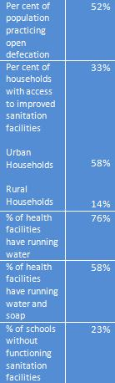
Access to clean water/sanitation (Claire)
- Source: UNICEF
- The public health issue of sanitation has two facets- facilities and clean water access
- Facilities:
  - Only 33% of population has access to proper sanitation facilities
  - Diarrhea is the third most common cause for hospital attendance and the second highest cause for pediatric admissions
  - Increases the spread of disease
  - Ministry of Agriculture, Water, and Forestry
    - Increase bathrooms, particularly in schools
    - Teach proper usage and hand-washing
- Access to clean water:
  - Open defecation due to lack of sanitary bathrooms contaminates water supply
  - In urban areas: 98% of households have clean water supply
  - In rural areas: only 59%
    - Rivers, streams & wells
  - Government of Namibia spending $2.6 billion on improving rural water supply & sanitation
    - Build desalination plant on the coast to make salty ocean water drinkable
  - “Through improving access to safe water, improvements in health and the decrease in the spread of disease will also occur. Eliminating these conditions will lead to major improvements in health, even helping combat the prominence of diseases such as diarrhea and cholera.” -The Borgen Project
    - [Global non-profit that does work with water supply in Namibia as well as other things]

- Healthcare (access to… present healthcare system)-Haley, Olivia
  - http://www.fhi360.org/projects/communication-change-c-change-namibia
  - http://www.thevillager.com.na/articles/5808/State-of-Health-System-in-Namibia/
    - Healthcare system used to be used mostly for curative care and was inefficient and inadequate
    - Those who were poor and disadvantaged were unable to access care at independence (this is still present today)
    - This has a lot to do with discrimination of economic and social policies of the apartheid
    - Medical funds are still in control by those who were previously advantaged
    - Empirical studies- show that health improvements help foster economic growth in developing countries
    - Better health and better income have a positive correlation
    - Namibian government gave $6.2b to the health sector in 2014-2015
    - “WHO defines health as a state of complete physical, mental and social well being and not merely the absence of disease or infirmity.”
      - This can be achieved by having accessible, affordable, and comprehensive healthcare for all (include prevention)
      - Today low income groups do not have access to such care
    - Nine medical aid funds in Namibia- four of which are open funds to which anyone can join
      - 1.7 million Namibians are not members of a fund- depend on state healthcare
      - Many people do not know about the management of medical aid funds- benefits the wealthy and those in charge

  - http://allafrica.com/stories/201309270402.html
    - Minister of Health and Social Services- Dr. Richard Kamwi- government is working to make sure that there is equal access to healthcare across the nation
    - Work has been done with the Social Security Commission with the goal of creating some sort of system to help make healthcare accessible to everyone
  - http://www.namaf.org.na Namibia Association of Medical Funds
    - Medical Aids Fund Act of 1995- “control, promote, encourage and co-ordinate the establishment, development and functioning of Medical Aid Funds in Namibia”
    - goal of this group is to provide affordable and comprehensive healthcare to all
  - http://www.our-africa.org/namibia/poverty-healthcare
    - Healthcare in Namibia is better in comparison to other countries in Africa
    - More medical professionals
    - Mobile clinics are present in rural areas- quality may not be as great in certain areas
    - Only ⅓ of people have proper toilets
    - poor hygiene particularly affects young children

_______________________________________________________________

public health services overseen by the Ministry of Health and Social Services
- 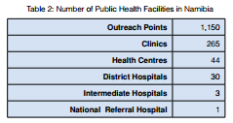
- estimated that public healthcare facilities serve 85% of the namibian population
  - mostly accessed by lower income groups
- private, for-profit healthcare system serves the other 15%
  - middle to higher income groups
- major challenges
  - communicable diseases
  - high maternal mortality
  - child malnutrition
  - institutional capacity gaps
  - inadequate organizational development
- access to healthcare concerns
  - remoteness and long distances
  - 3 workers per 1000 people (slightly above WHO recommendation)
  - skills shortage in the public sector (barely 2 workers/1000 people)
  - shortage of doctors and nurses
- Health sector partners

  - private
    - regulated by the Hospitals and Health Facilities Act of 1994
    - 844 private health facilities registered with the MoHSS
    - financial constraints
  - donor
    - spending has doubled over the past 5 years because of donor contributions
    - about 79% of all donor funding went toward health in Namibia in the 2006/2007 year, as opposed to the 7.2% from the 2001/2002 year
    - why?
      - AIDS, TB. and malaria funding from various organizations
  - UN
    - agencies of the United Nations and WHO are also involved in funding Namibia’s healthcare system
  - civil society
    - churches and NGOs
    - particularly involved in the delivery of healthcare at the community level
    - problems with sustainability, funding, skills gaps, etc. challenge most NGOs
natural disaster/emergency preparedness is less than ideal
- compromises access to healthcare facilities
- the populations that they need to reach often exceed the health worker’s capacity
- the government recognizes the flaws in the pre-emergency period and is working to establish and improve disaster risk reduction and emergency preparedness and response at national, regional, and local levels

_________________________________________________________________________

Prevention methods in place (overlap with education)-Kendra
http://www.cdc.gov/globalhealth/countries/namibia/

    - The Center for Disease Control and Prevention (CDC) has partnered with Namibia since 2002
    - The government works with the Ministry of Health and Social Services
    - U.S. President’s Emergency Plan for AIDS Relief (PEPFAR)
      - The CDC gives assistance and financial support for access to:
        - Antiretroviral Therapy
        - HIV counseling & Testing
        - Early infant diagnosis
        - Prevention methods of mother-to-child HIV transmission
    - The CDC is working with the MoHSS in improving the national public health sector
    - Prevention activities in place:
      - Evidence-based prevention→ PMTCT, male circumcision, blood safety, HIV counseling and testing, and the reduction of alcohol abuse
      - Improve lab systems/networks/other public health systems
      - Integrating primary health care services, HIV/AIDS, tuberculosis and maternal and child health services
      - Monitoring, evaluating, research and maintenance of health info systems
      - Improve quality of HIV treatment, training and mentoring
    - CDC supports the Namibia Institute of Pathology, the Polytechnic of Namibia, and MoHSS by training for lab workers, supporting for infrastructure projects.
    - Strong laboratory system has let Namibia to expand early infant HIV diagnoses and TB diagnostic services.
    - the first National Public Health Policy was developed and approved by the Namibian gov’t which is resulting in the creation of a National Public Health Laboratory
    - CDC directs assistance to MoHSS in strengthening the public health system & to improve lab systems
    - CDC supports giving primary health care services → want to integrate HIV/AIDS checks with tuberculosis/maternal/child health services

    - Supporting HIV research and health information systems
      - Activities
        - support was provided for harmonized indicators and data systems
        - Data triangulation exercises were implemented
        - Support for biological and behavioral surveillance activities was provided.

    - activities for HIV/AIDS efforts
      - Implement evidence-based prevention activities including PMTCT, male circumcision, blood safety, HIV counseling and testing, and the reduction of alcohol abuse.
      - Improve laboratory systems and networks and other public health systems.
      - Integrated primary health care services, HIV/AIDS, tuberculosis, and maternal and child health services.
      - Support HIV surveillance activities, monitoring and evaluation, research, and the maintenance of health information systems.
      - Improve the quality of HIV treatment, training, and mentoring.
  - Hospitals
    - 13 hospitals
      - Congestion in hospitals because ppl believe the primary care is better
    - 75 clinics
    - 8 health centers
      - 72% of Namibian doctors are in the private sector
      - Less than 50% are registered nurses
    - The 2008 HSSR discovered hospitals give all medical services
      - Serve as referral centers for health centers and clinics
      - Are available 24 hours a day
      - Suffer from: transportation logistics (figuring out movement of drugs and supplies and staff, supervising visits)

(mainly in urban areas of Erongo & Khomas regions)

  - How easy is it to get health assistance
    - The public sector cannot cater to all the needs at certain levels, so the MoHSS is looking to introduce new tech. and opportunities through the public-private partnership model
    - The WHO are developing District Health Packages (these aim at better human and financial resources at delivery levels)
    - Health promotion suffers→ Absence of health promotion strategies, capacity and resources
    - About 5000 community based health care providers have been trained in provision community health services (hygiene, prevention of diarrhoea)
    - The 13 regions have Regional Management Teams→ responsible for translation, implementation, and management of public health system in that region.
      - Includes hospitals
    - Oral and dental services are provided in 15 of 34 (44%) health district hospitals.

      - Areas that do not have oral/dental services are still served by outreach program.
      - Problems with oral/dental health:
        - lack of good dental instruments/materials
        - lack of transport
        - cannot get dental staff to HIV/AIDS workshops
        - only 1 dentist and dental therapist per region (except Khomas, Oshana & Otjozondjupa regions)
    - Social welfare sector provides treatmeMnt & rehabilitation services to people with drug & alcohol problems
      - Treatment centers exist
      - Treatment center appointments are followed up by after-care services (these play a key role in minimizing relapses)
      - Ministry runs outreach programs
        - Promote responsible lifestyles
      - Coalition on Responsible Drinking (CORD) → an alcohol & drugs campaign that talks about alcohol and drug abuse & promote responsible lifestyles.
      - Some regions (Erongo, Oshikoto, Omusati…) have regional and constituency CORD Committees)

    - Mental health?-Katie
      - A major cause of morbidity & mortality
      - Constraints Namibia faces:
        - lack of skilled labour and mental health facilities and equipment
        - lack of accessibility to services for population (especially for those in rural areas)

http://www.who.int/mental_health/evidence/atlas/profiles/nam_mh_profile.pdf?ua=1

A mental health plan exists and was approved, or most recently revised, in 2009. The mental health plan
components include:
● Timelines for the implementation of the mental health plan.
● Funding allocation for the implementation of half or more of the items in the mental health plan.
● Shift of services and resources from mental hospitals to community mental health facilities.
● Integration of mental health services into primary care.

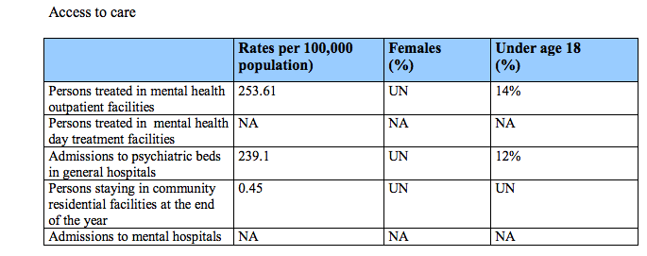
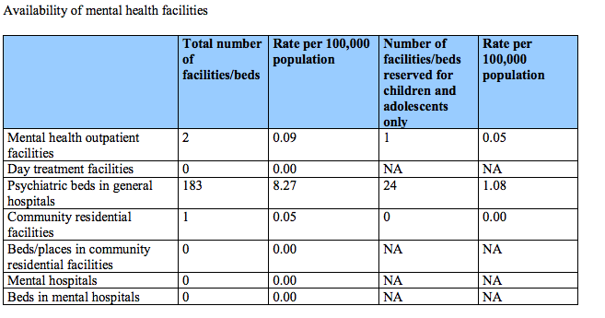

- Health History

