Namibia Agriculture, Geography, and Environment
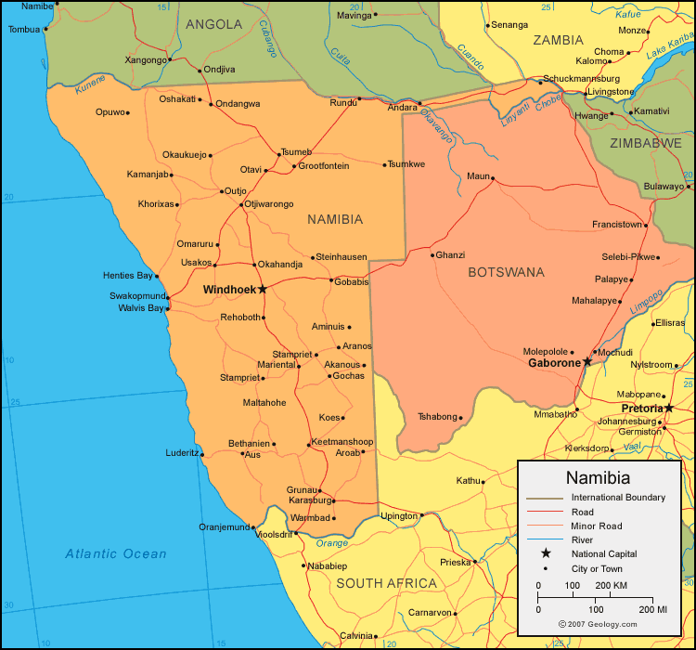
Namibia borders Angola, Zambia, Botswana and South Africa

2 major deserts: Kalahari and Namib

Over 18 protected areas and Parks in Namibia

Minister of Agriculture, Water and Forestry: John Mutorwa
Namibia Agricultural Union President: Derek Wright

Climate
- Over 300 sunny days
- Hot and arid
- 2 season
  - Summer (September-May)
    - 2 rainy seasons September-November and February-April
      - Rainfall is highly variable; often many droughts
  - Winter (June-August)
    - extremely dry

Environmental Issues
- Water
- Climate Change
- Habitat Fragmentation
- Wildlife Conversation
- Offshore Drilling
- Desertification

Agriculture
- 2% of land gets enough water for agriculture
- Agriculture makes up 5% of the countries GDP
- 30% of people rely on subsistence farming

